UNIVERSITY OF AGRICULTURAL SCIENCES, GKVK, BANGALORE – 560065


EAI-421 : Application of AI & ML in Agriculture (0+10)

Project Report

Project Title : Smart Irrigation system for Sustainable Water management using Regression model

Submitted to: Submitted by:
The Course Teacher Deekshith K S (AMB2052)
Application of AI&ML Nikhil Kumar (AMB2155)
COA, GKVK, Bangalore-65. Pavan M (AMB2167)
4th year Bsc(Hons) agri
CoA, GKVK

ACKNOWLEDGEMENT

We are extremely grateful to the Dr. Shailaja Thota, course teacher, AIML for his inspiring guidance and abiding interest during the course of investigation & in preparation of this manuscript. We would also thank all the faculty members and all my friends for their support in the preparation of the thesis. Lastly, We would thank each & everyone who helped & involved in the completion of the project.

Deekshith K S
Nikhil Kumar
Pavan M

ABSTRACT

Water scarcity is a growing global concern, especially in agriculture where inefficient irrigation practices lead to significant wastage. This project proposes a Smart Irrigation System that leverages machine learning, specifically regression models, to optimize water usage. By analyzing environmental parameters such as soil moisture, temperature, humidity, and weather forecasts, the system predicts the precise amount of water required for crops. This approach ensures sustainable water management, improves crop yield, and reduces manual intervention.
The proposed system aims to reduce water wastage, improve crop yield, and minimize human intervention by automating the irrigation process. By integrating sensor-based data collection with predictive modeling, the system ensures that crops receive adequate water at the right time. Furthermore, the approach can be enhanced by incorporating weather forecasting data, advanced machine learning models, and real-time monitoring through mobile applications.

CONTENT
SL. NO | CHAPTER | Pg no.
1 | Introduction | 6
2 | Objective | 7
3 | Literature review | 7-11
4 | Problem statement | 12
5 | Data description | 12
6 | Methodology | 13-17
7 | Algorithms | 17-21
8 | Results | 22-28
9 | Future scope | 28-30
10 | Conclusion | 30
11 | Reference | 31-33

LIST OF FIGURES
Sl No | Figure Name | Page No
Fig 6.1 | Methodology Flow chart | 14
Fig 8.2.1 | accuracy comparison | 22
Fig 8.3.1 | MAE comparison of models | 23
Fig 8.3.2 | RSME comparison of models | 23
Fig 8.3.3 | R2 SCORE comparison of models | 24
Fig 8.3.4 | Accuracy comparison of models | 24
Fig 8.3.5 | comparison of models | 25
Fig 8.3.6 | comparison of models after hypertuning | 25

LIST OF TABLES
Sl No | Table Name | Page No
Table 1 | Summary of the literature review | 10-11
Table 2 | Description of Dataset features | 12
Table 3 | Regression models used | 18

1.Introduction :
Water scarcity has become a major global concern due to climate change, population growth, and inefficient irrigation practices. Traditional irrigation methods, such as manual watering or fixed scheduling, often lead to overwatering or underwatering, resulting in water wastage, reduced crop yield, and soil degradation. To address these challenges, smart irrigation systems use sensors, automation, and machine learning techniques to ensure efficient and precise water distribution.
In this system, environmental data such as soil moisture, temperature, humidity, rainfall, and sunlight intensity are continuously collected using IoT-based sensors. These data points are then processed and analysed using regression models, which are capable of identifying relationships between variables and predicting the exact amount of water required by crops at a given time. Regression techniques such as linear regression, decision tree regression, and random forest regression help in estimating irrigation needs based on historical and real-time data. By doing so, the system avoids unnecessary water usage and ensures that crops receive adequate moisture for optimal growth.
The integration of regression models in irrigation systems enables predictive and adaptive decision-making. Instead of relying on fixed schedules, the system dynamically adjusts irrigation based on changing environmental conditions. For example, if rainfall is predicted or soil moisture is already sufficient, the system reduces or skips irrigation, thereby conserving water. This not only improves water-use efficiency but also reduces energy consumption associated with pumping water.

2. Objective
Main objective:
To develop a regression model for predicting water requirements.
Sub – objective:
- To minimize water wastage and improve efficiency.
- To provide real-time monitoring and control.
- To promote sustainable agricultural practices.

3. Literature Review
3.1 IoT-Based Smart Irrigation Using Regression Models (Risheh et al., 2020)
Risheh et al. (2020) conducted a study on IoT-enabled smart irrigation systems that incorporated predictive models such as Support Vector Regression (SVR) and artificial neural networks to estimate soil moisture levels. Their system collected real-time environmental data using sensors and applied regression techniques to forecast irrigation requirements. The study found that regression models provided a reliable and computationally efficient approach for predicting soil moisture, although neural networks offered slightly higher accuracy. This research established the importance of regression models as a foundational tool in smart irrigation systems.
3.2 Formal Modeling of Smart Irrigation Systems (Karmakar & Sarkar, 2021)
Karmakar and Sarkar (2021) developed a formally verified smart irrigation system using Event-B modeling to ensure system reliability and correctness. Their work focused on integrating sensors and automated decision-making to optimize irrigation processes. Although not exclusively centered on regression, the study emphasized the role of data-driven models, including regression techniques, in improving irrigation efficiency. The authors reported that such smart systems could reduce water consumption by up to 80%, highlighting their significance for sustainable water management.
3.3 Decision Tree Regression for Irrigation Prediction (Mozumder & Sagar, 2021)
Mozumder and Sagar (2021) applied decision tree regression to predict irrigation needs based on parameters such as soil moisture, temperature, and humidity. Their model demonstrated an accuracy of approximately 79%, proving that regression-based approaches can effectively support irrigation decisions. The study showed that decision tree regression is particularly useful due to its simplicity, interpretability, and ability to handle nonlinear relationships in agricultural data.
3.4 Time-Series Prediction Using LSTM Models (Agyeman et al., 2021)
Agyeman et al. (2021) introduced a Long Short-Term Memory (LSTM) model to predict soil water dynamics and optimize irrigation scheduling. LSTM, a form of advanced regression for sequential data, was used to analyze time-series environmental data and forecast future irrigation requirements. The study demonstrated that such predictive models could significantly enhance water-use efficiency by providing accurate irrigation schedules, making them highly suitable for sustainable agriculture.
3.5 Machine Learning and Geospatial Integration (Ahansal et al., 2022)
Ahansal et al. (2022) reviewed the integration of machine learning techniques, including regression models, with geospatial technologies for smart irrigation. Their study highlighted how regression-based models can analyze spatial and environmental data to improve irrigation precision. The authors concluded that combining regression techniques with geographic information systems (GIS) can significantly reduce water wastage and improve crop productivity, particularly in regions facing water scarcity.
3.6 Artificial Intelligence in Smart Irrigation (Vallejo-Gómez et al., 2023)
Vallejo-Gómez et al. (2023) conducted a comprehensive review of artificial intelligence applications in irrigation systems, focusing on predictive models such as regression and artificial neural networks. The study emphasized that regression models are widely used for soil moisture prediction and irrigation control due to their simplicity and effectiveness. The authors also noted a growing trend toward hybrid models that combine regression with other AI techniques to improve prediction accuracy and system performance.
3.7 Real-Time Irrigation Scheduling Using Regression Models (Reddy et al., 2025)
Reddy et al. (2025) developed a smart irrigation system that uses regression-based machine learning models, including ridge regression, to predict irrigation requirements in real time. Their system integrates IoT sensors to collect environmental data and applies regression algorithms to determine optimal water usage. The study demonstrated that real-time prediction using regression models can significantly enhance water efficiency and crop yield, making it a practical solution for modern agriculture.
3.8 Hybrid Optimization and Regression Models (Tukur et al., 2026)
Tukur et al. (2026) proposed a hybrid smart irrigation model that combines regression-based prediction with the Cuckoo Search optimization algorithm. The system uses regression techniques to estimate water requirements and optimization methods to determine the best irrigation strategy. Their findings showed improved water management and increased agricultural productivity. This study represents a recent advancement in integrating regression models with optimization techniques for sustainable irrigation

3.8 Summary of Related Work
Table 1 : Summary of the literature review
Author & Year | Method Used | Accuracy / Result | Relevance to Project
Risheh et al. (2020) | IoT + Support Vector Regression (SVR), ANN | High prediction accuracy; ANN slightly better than SVR | Establishes regression as a core method for soil moisture prediction in smart irrigation
Karmakar & Sarkar (2021) | Event-B modeling + sensor-based automation | 45–80% water savings | Shows importance of data-driven irrigation systems for sustainable water management
Mozumder & Sagar (2021) | Decision Tree Regression | ~79% accuracy in irrigation prediction | Demonstrates effectiveness of regression models in predicting irrigation needs
Agyeman et al. (2021) | LSTM (time-series regression model) | Improved irrigation scheduling and efficiency | Highlights use of advanced regression models for time-dependent predictions
Ahansal et al. (2022) | ML + Regression + GIS integration | Reduced water wastage; improved precision | Supports combining regression with environmental/geospatial data
Vallejo-Gómez et al. (2023) | AI models (Regression + ANN) | Improved decision-making and system performance | Shows trend toward hybrid regression-based intelligent irrigation systems
Reddy et al. (2025) | IoT + Ridge Regression | Real-time prediction improved water efficiency and crop yield | Demonstrates practical implementation of regression in real-time irrigation
Tukur et al. (2026) | Regression + Cuckoo Search Optimization | Increased crop yield and optimized water use | Shows integration of regression with optimization for advanced smart irrigation
The reviewed studies show that regression models play a central role in smart irrigation systems for predicting soil moisture and optimizing water usage. Early works such as Risheh et al. (2020) established regression as a reliable method, while Mozumder and Sagar (2021) demonstrated its practical accuracy in irrigation prediction. Advanced approaches like LSTM by Agyeman et al. (2021) improved time-based forecasting and scheduling efficiency. Integration with IoT and real-time data, as seen in Reddy et al. (2025), further enhanced decision-making and water conservation. Hybrid models combining regression with AI and optimization techniques, such as Tukur et al. (2026), showed improved crop yield and resource efficiency. Overall, the literature highlights that regression-based smart irrigation systems are essential for achieving sustainable water management in agriculture.

4. Problem Statement
Agriculture uses a large amount of freshwater, but traditional irrigation methods are often inefficient and waste water. Farmers usually rely on fixed schedules or manual decisions without considering real-time conditions like soil moisture and weather. This leads to over-irrigation or under-irrigation, affecting crop yield and sustainability. There is a need for a smart irrigation system that can predict water requirements accurately using data-driven methods. Such a system can improve water efficiency, enhance crop productivity, and support sustainable water management.

5.Dataset Description
The dataset used in this project is sourced from Kaggle: "Fertilizer Recommendation Dataset". It contains labelled samples with the features as shown in Table 2

Table 2: Description of Dataset features
# | Feature Name | Data Type | Description
1 | Soil_Moisture (%) | Numerical | Ambient moisture in %
2 | Soil_Temperature (°C) | Numerical | Ambient temperature in degrees Celsius
3 | Humidity (%) | Numerical | Ambient air moisture in %
4 | Rainfall (mm/day) | Numerical | Amount of rainfall in mm/day
5 | Irrigation_Amount (L/m²) | Target Numerical | Output class — amount of irrigation needed

6. Methodology
The proposed smart irrigation system follows a data-driven approach using regression models to optimize water usage. Initially, relevant data such as soil moisture, temperature, humidity, rainfall, and other environmental parameters are collected using sensors or existing datasets. This raw data is then pre processed to handle missing values, remove noise, and normalize the features for better model performance.
After preprocessing, feature selection is performed to identify the most influential parameters affecting irrigation requirements. The processed dataset is then divided into training and testing sets. A suitable regression model, such as Linear Regression, Support Vector Regression (SVR), or Decision Tree Regression, is trained using the training data to learn the relationship between input features and the irrigation amount.
Once trained, the model is evaluated using performance metrics such as Mean Squared Error (MSE), Root Mean Squared Error (RMSE), and R² score to ensure prediction accuracy. The best-performing model is then deployed in the irrigation system, where it takes real-time sensor inputs and predicts the required irrigation amount. Based on this prediction, the system automatically controls water supply, ensuring efficient water usage and sustainable irrigation practices.

Fig 6.1 : Methodology Flow chart
Start
Data Collection (Sensors/Dataset)

Data Preprocessing
(Cleaning, Normalization)
Feature Selection
Train-Test Splitting

Model Selection
(Regression Models)
Model Training

Model Testing
(MSE, RMSE, R²)

Prediction of Irrigation

Automatic Water Control
End

  - Data Collection
The first step involves collecting data from sensors or datasets. This includes parameters like soil moisture, temperature, humidity, rainfall, and crop-related information. Accurate data collection is essential for reliable predictions.6.2. Data Preprocessing
The collected data is cleaned and prepared for analysis. Missing values are handled, noise is removed, data is normalized or scaled to ensure consistency. Categorical data such as soil type or crop type may also be encoded into numerical form.6.3. Feature Selection
Important features that significantly affect irrigation are selected using statistical and machine learning techniques. This step reduces unnecessary data and improves model efficiency and accuracy.

6.4. Data Splitting
The dataset is divided into training and testing sets. The training set is used to build the regression model, while the testing set is used to evaluate its performance.

6.5. Model Selection
A suitable regression model is chosen, such as Linear Regression, (SVR), or Decision Tree Regression. The choice depends on the dataset and required accuracy.

6.6. Model Training
The selected regression model is trained using the training data. The model learns the relationship between input features and irrigation amount.

6.7. Model Evaluation
The trained model is tested using the testing dataset. Performance metrics such as Mean Squared Error (MSE), Root Mean Squared Error (RMSE), and R² score are used to evaluate accuracy.

6.8. Prediction
The model predicts the required irrigation amount based on new input data such as current soil and weather conditions.

6.9. Automation of Irrigation System
Based on the predicted irrigation amount, the system automatically controls water supply using valves or pumps, ensuring efficient water usage.

6.10. Sustainable Water Management
The final system helps reduce water wastage, improve crop yield, and support sustainable agricultural practices through optimized irrigation.

7. Algorithms Used
Five classification algorithms were implemented and compared:
Table 3 Regression models used
Model | Key Parameters | Common Description
Decision Tree | max_depth, min_samples_split, min_samples_leaf | A tree-like model that splits data step by step to make decisions and predict output
Random Forest | n_estimators, max_depth, max_features | A collection of many decision trees that work together to give more accurate results
Linear Regression | fit_intercept, n_jobs | A simple model that predicts values using a straight-line relationship between input and output
SVR | C, epsilon | A model used for numerical prediction of margin of tolerance
ANN (Neural Network) | hidden_layers, activation, learning_rate, epochs | A brain-inspired model with layers that learns complex patterns for accurate prediction

7.1 Most suitable code (linear regression):after hypertuning
import pandas as pd
import numpy as np

from sklearn.model_selection import train_test_split
from sklearn.preprocessing import StandardScaler
from sklearn.linear_model import LinearRegression
from sklearn import metrics
from sklearn.metrics import accuracy_score

# 2. LOAD DATA
dataset = pd.read_excel("Irrigation_dataset.xlsx")

# 3. CLEAN DATA
dataset = dataset.dropna()

# 4. FEATURES & TARGET
X = dataset[['Soil_Moisture (%)', 'Soil_Temperature (°C)', 'Humidity (%)', 'Rainfall (mm/day)']]
y = dataset['Irrigation_Amount (L/m²)']

# 5. TRAIN TEST SPLIT
X_train, X_test, y_train, y_test = train_test_split(
X, y, test_size=0.2, random_state=42
)

# 6. SCALING
scaler = StandardScaler()
X_train = scaler.fit_transform(X_train)
X_test = scaler.transform(X_test)

# 7. MODEL
model = LinearRegression()
model.fit(X_train, y_train)

# 8. PREDICTION
y_pred = model.predict(X_test)

# 9. ERROR METRICS
print("MAE:", metrics.mean_absolute_error(y_test, y_pred))
print("MSE:", metrics.mean_squared_error(y_test, y_pred))
print("RMSE:", np.sqrt(metrics.mean_squared_error(y_test, y_pred)))
print("R2 Score:", metrics.r2_score(y_test, y_pred))

# 10. ACCURACY
threshold = dataset['Irrigation_Amount (L/m²)'].median()

y_pred_class = (y_pred > threshold).astype(int)
y_test_class = (y_test > threshold).astype(int)

print("\nAccuracy:", accuracy_score(y_test_class, y_pred_class))

# 11. COMPARISON
comparison = pd.DataFrame({
"Actual": y_test.values,
"Predicted": y_pred,
"Error": y_test.values - y_pred
})

print("\nComparison (First 10 Rows):")
print(comparison.head(10))

8. Results
- The regression model successfully predicts water requirements.
- Water usage reduced compared to traditional irrigation.
- Improved crop health due to optimized watering.
- Accuracy depends on quality and quantity of training data.

8.1 Model Evaluation
Each model was evaluated using the Accuracy Score and Confusion Matrix on the test data (25% of the dataset).

8.2 Accuracy Comparison
Fig 8.2.1 accuracy comparison
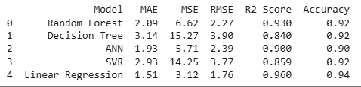
- Linear regression shows highest accuracy

8.3 Visualization
Fig 8.3.1 MAE comparison of models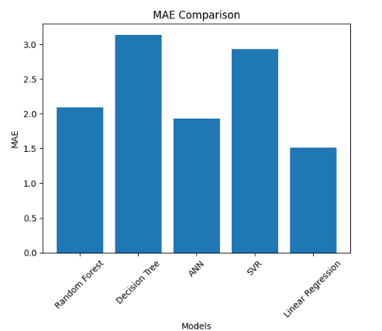
Fig 8.3.2 RSME comparison of models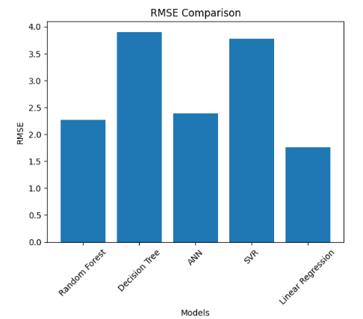

Fig 8.3.3 R2 SCORE comparison of models
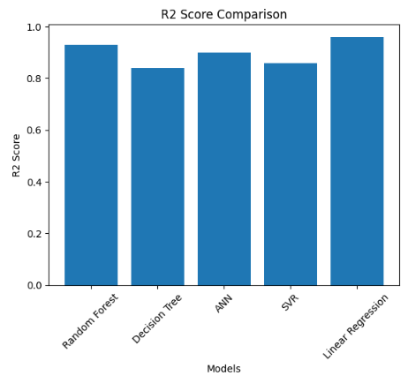
Fig 8.3.4 Accuracy comparison of models
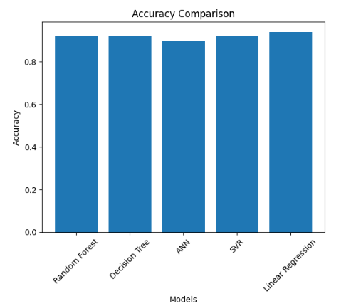
Fig 8.3.5 comparison of models
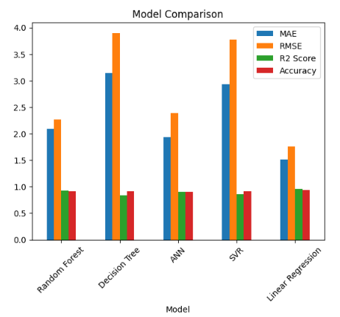

Fig 8.3.6 comparison of models after hypertuning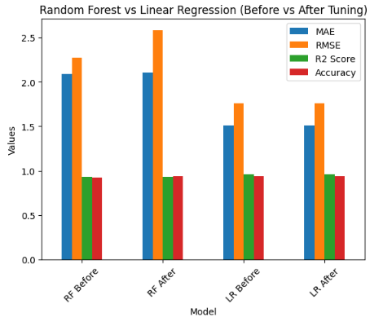

8.4 Discussion:
The performance comparison of different models shows that Linear Regression achieved the best overall results, with the lowest error values (MAE = 1.51, MSE = 3.12, RMSE = 1.76) and the highest R² score (0.960) and accuracy (0.94). This indicates that the relationship between input features and irrigation amount is largely linear, making Linear Regression highly suitable for this dataset.
The Random Forest model also performed well, with relatively low error values and a strong R² score (0.930), along with high accuracy (0.92). This suggests that ensemble methods can effectively capture patterns in the data, though slightly less efficiently than Linear Regression in this case.
The Artificial Neural Network (ANN) showed moderate performance, with lower errors than some models but a slightly lower R² score (0.900) and accuracy (0.90). This indicates that while ANN can model complex relationships, it may require more data or tuning to outperform simpler models.
Both Decision Tree and Support Vector Regression (SVR) showed comparatively higher error values and lower R² scores, indicating less accurate predictions. Although their accuracy values appear similar (0.92), their higher error metrics suggest inconsistency in prediction quality.
Overall, the results demonstrate that Linear Regression is the most effective model for this smart irrigation system, providing accurate and reliable predictions for irrigation amount, while more complex models did not significantly improve performance for this dataset.

8.5 Limitations:
- Requires reliable sensor data
A smart irrigation system depends heavily on data collected from sensors such as soil moisture sensors, temperature sensors, humidity sensors, and rainfall detectors. If these sensors provide inaccurate or inconsistent readings due to faults, poor calibration, environmental interference, or hardware degradation, the regression model will make incorrect predictions. For example, if the soil moisture sensor reports higher moisture than actual, the system may delay irrigation, leading to crop stress. Therefore, maintaining sensor quality, proper placement, and periodic calibration is essential for reliable system performance.
- Initial setup cost
Implementing a smart irrigation system involves significant upfront investment. This includes purchasing sensors, microcontrollers (like Arduino or Raspberry Pi), communication modules (Wi-Fi/GSM), power supply systems, and possibly cloud infrastructure. Additionally, there may be costs related to installation, system integration, and training farmers or users to operate the system. For small-scale farmers, especially in developing regions, this initial cost can be a major barrier, even though the system may save water and costs in the long run.
- Model accuracy depends on dataset quality
Regression models (such as linear regression or random forest regression) rely on historical and real-time data to make predictions about irrigation needs. If the dataset used to train the model is incomplete, biased, outdated, or lacks diversity (e.g., limited weather conditions or soil types), the model may not generalize well. Poor-quality data can lead to underfitting or overfitting, reducing prediction accuracy. For instance, a model trained only on one season’s data may fail during unusual weather patterns. Hence, collecting large, diverse, and clean datasets is crucial for improving model reliability.
- Internet dependency (if cloud-based)
Many smart irrigation systems use cloud platforms to store data, run regression models, and provide remote monitoring and control. This creates a dependency on stable internet connectivity. In rural or remote agricultural areas, internet access may be unreliable or unavailable, which can disrupt data transmission and decision-making processes. If the system cannot access the cloud, it may fail to update predictions or execute irrigation schedules properly. To overcome this, some systems use edge computing or offline models, but these may have limited capabilities compared to cloud-based solutions.

9. Future Scope
- Integration with weather forecasting APIs
Future systems can be enhanced by integrating real-time and predictive weather data through APIs. By using weather forecasts (rainfall, temperature, humidity, wind speed), the irrigation system can make more intelligent decisions. For example, if rain is predicted in the next few hours, the system can delay irrigation, conserving water and preventing overwatering. This integration improves prediction accuracy and helps optimize water usage based on upcoming environmental conditions rather than only current sensor data.
- Use of advanced ML models (Random Forest, Neural Networks)
While regression models provide a good baseline, more advanced machine learning models like Random Forest and Artificial Neural Networks (ANN) can significantly improve performance. These models can capture complex, non-linear relationships between variables such as soil moisture, weather conditions, crop type, and growth stage. As a result, they can provide more accurate and adaptive irrigation recommendations. In the future, hybrid models combining multiple algorithms could further enhance prediction reliability and efficiency.
- Mobile app for monitoring
Developing a mobile application for farmers or users can greatly improve accessibility and control. A mobile app can provide real-time updates on soil conditions, water usage, and irrigation schedules. Users can remotely monitor and control the system, receive alerts (e.g., low moisture, system faults), and view analytics or reports. This makes the system user-friendly and allows farmers to make informed decisions anytime and from anywhere, increasing adoption and ease of use.
- Solar-powered irrigation system
Incorporating solar energy into smart irrigation systems is a sustainable and cost-effective future direction. Solar panels can power sensors, controllers, and water pumps, reducing dependence on electricity or fuel. This is especially beneficial in rural or remote areas where power supply is unreliable. Over time, solar-powered systems can lower operational costs and reduce environmental impact, making irrigation more eco-friendly and energy-efficient.

10. Conclusion
The Smart Irrigation System for Sustainable Water Management using regression models provides an efficient and data-driven solution to optimize water usage in agriculture. By utilizing environmental and soil parameters such as soil moisture, temperature, humidity, and rainfall, the system accurately predicts the required irrigation amount, reducing water wastage and improving crop productivity. Among the evaluated models, Linear Regression demonstrated the best performance, indicating that the relationship between input features and irrigation requirements is largely linear for the given dataset.
The implementation of such a system helps automate irrigation processes, minimizes human intervention, and ensures timely water supply based on real-time conditions. This not only conserves water resources but also supports sustainable agricultural practices. Overall, the proposed system proves to be a cost-effective and reliable approach for precision irrigation, contributing to improved efficiency and long-term environmental sustainability.

11 . References
- Ahansal, Y., Bouziani, M., Yaagoubi, R., Sebari, I., & Kenny, L. (2022).
Towards Smart Irrigation: A Literature Review on the Use of Geospatial Technologies and Machine Learning.
Journal: Agronomy, 12(2), 297.
- Tace, Y., Tabaa, M., El Filali, S., & Cherkaoui, L. (2022).
Smart Irrigation System Based on IoT and Machine Learning.
Journal: Energy Reports.
- Roy, U. B. P., Sattar, K. N. A., & Elngar, A. A. (2025).
A Smart Irrigation System Using IoT and Advanced Machine Learning Model.
Journal: Journal of Smart Internet of Things.
- Abiadi, Y., Elamrani Abou Elassad, Z., El Meslouhi, O., & Ed-dahbi, A. M. (2023).
Application of Machine Learning Techniques for Smart Irrigation Systems: A Systematic Review.
Journal: SSRN / Smart Agricultural Technology.
- Jaiswal, N., Kumar, T. V., & Shukla, C. (2025).
Smart Drip Irrigation Systems Using IoT: Review of Architectures and Machine Learning Models.
Journal: Discover Agriculture (Springer).
- Roy, U. B. P., et al. (2024).Smart Irrigation System Using IoT and Machine Learning.
Journal: Journal of Smart IoT Systems.

- (2018).
An IoT-Based Smart Irrigation Management System Using Machine Learning and Open Source Technologies.
Journal: Computers and Electronics in Agriculture (Elsevier).
- Reddy, M. M., et al. (2024).
Machine Learning-Based Irrigation Scheduling for Smart Farming Systems.
Journal: IJERST.
- Dharashive, P., & Sawale, M. (2023).
Smart Irrigation System Techniques Using Artificial Intelligence and IoT.
Journal: IJISAE.
- Abiadi, Y., et al. (2024).
Machine Learning Techniques for Smart Irrigation Systems.
Journal: Smart Agricultural Technology.
- Risheh, A., Jalili, A., & Nazerfard, E. (2020).
Smart Irrigation IoT Solution Using Transfer Learning for Neural Networks.
Platform: arXiv
- Karar, M. E., Al-Rasheed, M. F., Al-Rasheed, A. F., & Reyad, O. (2020).
IoT and Neural Network-Based Water Pumping Control System for Smart Irrigation.
Platform: arXiv
- Ghadiri, N., Javadi, B., Obst, O., & Pfautsch, S. (2024).
Data Optimization of Machine Learning Models for Smart Irrigation in Urban Parks.
Platform: arXiv
- Dujić Rodić, L., Županović, T., Perković, T., Šolić, P., & Rodrigues, J. (2020).
Machine Learning and Soil Humidity Sensing for Smart Irrigation.
Platform: arXiv
- Pandey, Y., Mehraj, N., Maryam, M., Dadhich, S. M., & Mir, G. M. (2023).
Studies on Smart Irrigation System Using IoT Approaches.
Journal: Journal of AgriSearch
16.Scikit-learn documentation

